IMonitorEAM Installation Manual

Thank you for using IMonitor EAM - the advanced employees monitoring solution.
IMonitor EAM version 8.2
Date Updated: 5th - 7 - 2014

Catalogue
IMonitor EAM Installation: 1
Install IMonitor EAM Console Program and Server Program 1
Install IMonitor EAM Agent Program 2
Direct Agent installation: 2
Install Agent Remotely: 3
About Antivirus 5
About Firewall 5
Uninstall IMonitor EAM: 6
Uninstall Imonitor Server and Console: 6
Uninstall IMonitor EAM Agent Remotely: 6
Uninstall IMonitor EAM Agent directly: 6
IMonitor EAM System Requirements 6
Supported Network Enviroments 7
Appendix 8
How to Check IP Address of Server PC 8
How to Change Database Directory 9
How to Change Account Password 9

IMonitor EAM Installation:

First, extract all files from imonitor-professinal.zip/imonitor-standard.zip archive which you can download from our official website –www.imonitorsoft.com.

EAMProTrial8.2.exe/EAMStdTrial8.2.exe is the installer file-- this file includes IMonitor EAM console program , server program and agent program, compatible with Windows 2000/XP/Vista/7/8, Windows server 2000/2003/2008/2010, 32bit and 64 bit. The console program and server program should be installed on manager's computer while agent program on employees' computers.

Install IMonitor EAM Console Program and Server Program
To install IMonitor EAM console program and server program on your computer:
1. Run EAMProTrial8.2.exe or EAMStdTrial8.2.exe

2. Read the license agreement. If you accept the terms of agreement, tick "I accept the agreement" and click " Next".

3. Select directory where you want to install IMonitor EAM. Choose whether you want to create start menu group, wether to run application after installation process, and whether to put the IMonitor EAM shortcut on the desktop.

4. Wait until program files are copied to the destination folder.

5. Open IMonitor EAM from the Windows Start menu.

Install IMonitor EAM Agent Program

Direct Agent installation:
1. Please add EAM Agent folder "C:\windows\system\sys\syscon" into the exclusion list of the antivirus.

2. Disable antivirus.

- Click Home -> Install Agent -> Locate Agent Installer File, you will get the Agent installer file "AgentInstall.exe".
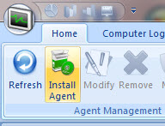

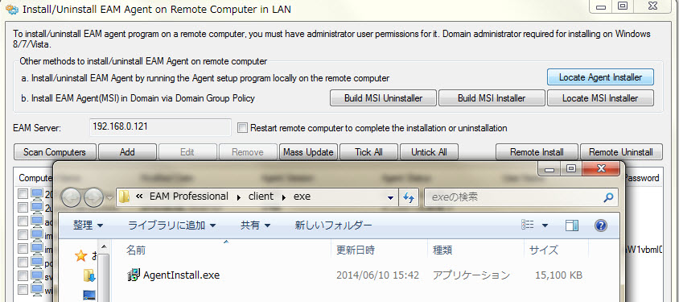
4. Go to the remote computer that you want to monitor.

5. Make sure this computer is connected to network and TCP/IP protocol is installed properly.

6. Transfer "AgentInstall.exe" to this computer and run it.

7. Read the license agreement. If you accept the terms of agreement, tick "I accept the agreement".

- Input server computer's IP address or computer name, server computer is the computer on which IMonitor EAM server program has been installed.
Method of checking sever PC’s IP address is on page 8.

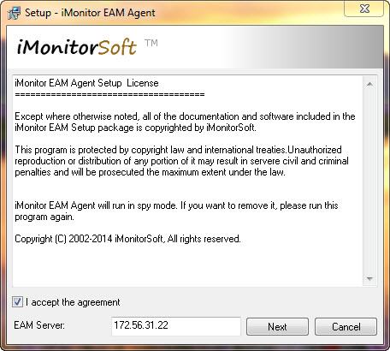

9. Click ‘next’ to install the Agent program.

10. Enable antivirus.

NOTE: When the installation was finished, please click Home -> Refreh to update the computer list.
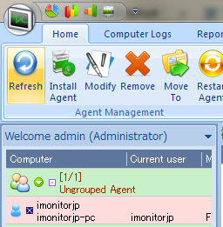

Install Agent Remotely:
Here are steps you need to follow to install the Agent remotely.
1. Click Home -> Install Agent.

2. Click 'Scan Computers' to add all network computers to the list or click 'Add' to add computers one by one.

3.Double click destination computers and input remote login Administrator name and password for each of them in the poped up window, if the computers are domain based, you can click 'Mass Update' to set domain administrator name and password for all computers.
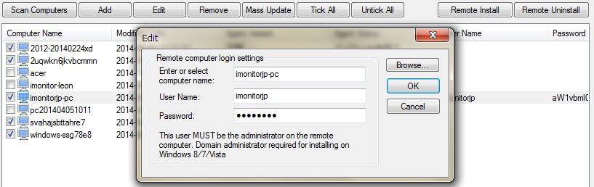

4. Tick destination computer(s) in the list.

5. If you want the remote computer to reboot automatically to complete the installation, please tick "Restart remote computer to complete the installation / uninstallation".
6. Click Remote Install.

7. The program will show you the install progress and result.
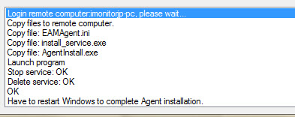

NOTE: When remote installation was finished, IMonitor EAM agent program will start after 1 minute, please click Home --> Refresh to refresh agent information.
* If remote installation fails, you have to get access to the computer you want to monitor to install it.

About Antivirus

How to add EAM console and server program into exclusion list of antivirus?
You have to add the EAM installation folder into the exclution list. For EAM Professional the default folder always is "C:\Program Files\EAM Professional", and for EAM Standard the the default folder always is "C:\Program Files\EAM Standard".

What to do when antivirus deleted some EXE file in iMonitor EAM folder?
1. Add EAM installation folder into the exclusion list of your antivirus.
2. Disable your antivirus.
3. Reinstall iMonitor EAM.
4. Enable your antivirus.

How to add agent program into the exclusion list of antivirus?
You have to add the EAM Agent folder into the exclution list. The agent installation folder is "C:\Windows\system\sys\syscon".

NOTE: Currently EAM is compatible and works smoothly with most popular anti-virus and firewall software, like Norton and kaspersky antivirus and firewall etc. But still anti-virus and firewall software would be considered by all the monitoring software company. If some errors occur like client can't connect or ping with server, please disable server and client anti-virus and firewall at first.

About Firewall

What ports and protocols dose iMonitor EAM use?
You have to enable port range 25790 - 25811, TCP and UDP on server computer.

Which applications belong to iMonitor?
EAM server: eamserver.exe, IMonLogCmd.exe, eamrdpsrv.exe, eamlogrec.exe
EAM Console: IMonitorMng.exe, eamrdp.exe, eamrdp2.exe
EAM Agent: mssys.exe
Please add above files to firewall's exclusion list.

Uninstall IMonitor EAM:

Uninstall Imonitor Server and Console:
1. If you have installed IMonitor EAM Agent to any remote computer, please Uninstall IMonitor EAM agent at first.
2. Exit IMonitor EAM console and server program.
3. Run Control Panel from Start menu.
4 Click Add/Remove Programs icon.
5. Select IMonitor EAM in the programs list and click Add/Remove button.
6. Wait for the program files to be deleted.

Uninstall IMonitor EAM Agent Remotely:
1. Click Home -> Install Agent.
2. Tick destination computer(s) in the list.
3. Please check the administrator name and password.
4. If you want the remote computer to reboot automatically to complete the Uninstallation, please tick "Restart remote computer to complete the installation / uninstallation".
5. Click Remote Uninstall.
6. The program will show you the uninstall progress and result.

Uninstall IMonitor EAM Agent directly:
Just run the Agent installer file ""AgentInstall.exe" on the computer, and input EAM admin password to uninstall it.

IMonitor EAM System Requirements

Operating Systems Supported
Windows 2000/XP/Vista/7/8, Windows server 2000/2003/2008/2010, 32bit and 64 bit.

Minimum Hardware Requirements
Client Hardware Requirements
* 500 MHz or faster processor
* 256 MB of RAM
* 1 GB of available hard disk space
Server Hardware Requirements
* 1 GHz or faster processor
* 256 MB of RAM
* 20 GB of available hard disk space
Recommended Hardware Requirements
Client Hardware Requirements
* 500 MHz or faster processor
* 256 MB of RAM or higher
* 1G of available hard disk space
Server Hardware Requirements
* 1G MHz or faster processor
* 512 MB of RAM or higher
* 120G MB of available hard disk space

Network Environment Requirements
Local Network Width Requirements
* 1MB or higher
Exclusive Network Width Requirements
* 2 MB or higher

Base on the minimum system requirements, below is how to set up the EAM working environment.

Since EAM uses unique database which IMonitor Software costs about one year
to develop, EAM will not require customer purchase other 3rd party database like
Microsoft SQL or MySQL etc any more. So one server computer and router which make client computers connect with server terminal will be enough to build up EAM working environment.

Supported Network Enviroments

VPN site-to-site connection
iMonitor EAM support site-to-site VPN connection, you can install EAM server in the main office, and monitor all remote computers from different sitess. And you can also use the Domain administrator to install agent program remotely.

Internet connection
IMonitor EAM support internet connection, you can install EAM server in United States, and install the client terminal in England, and you can monitor all the client computers and have all EAM features. If your EAM server computer use static internet IP address, it will be very easy, you only need to input the server ip address while installing the agent program. If you do not have a static internet ip address and you want to monitor computers on the internet (for example oversea client computers), you can setup DDNS(For example NO-IP.com) and register a free domain to deploy IMonitor EAM server on the internet.

Domain
IMonitor EAM Agent supports domain based computers. The agent program can be installed on computers in a domain.

Appendix

How to Check IP Address of Server PC
1. Open the server PC.
2. Click Start Button , input “cmd”, press Enter key.
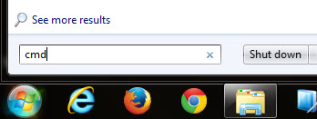
3. Input“ipconfig”and press Enter key.
4. You will see the IP address.
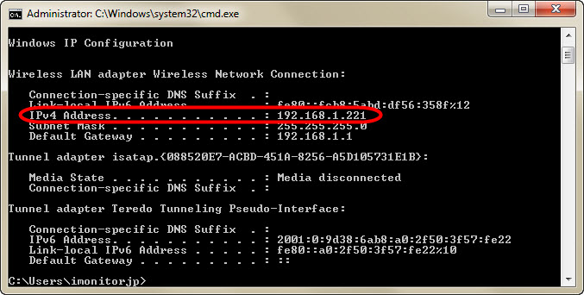

How to Change Database Directory
1. Click “Home -> DB settings”.
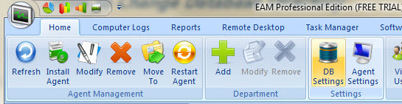
2. In the pop-up window you can change DB directory.
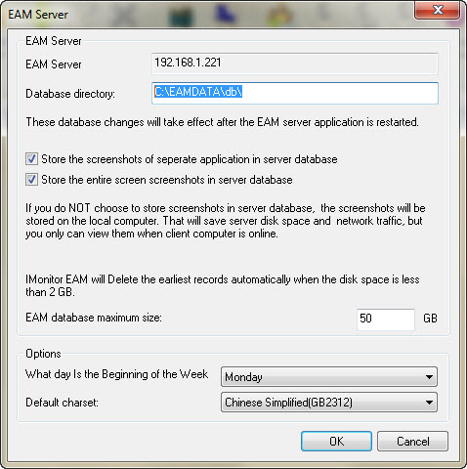

How to Change Account Password
Default password is “000”, to change it please ：

1. Click“Home -> View users”and click the user.
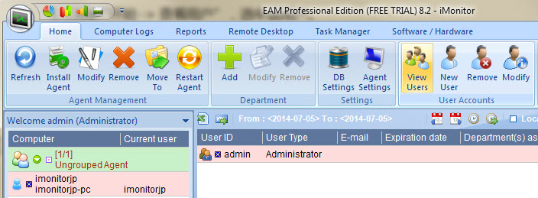
2. Hit “Modify”.
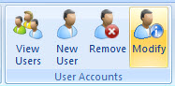
3. Input old password and new password . Click “OK”.
